Cyril Bernardo

Professor Sahin

Compressible Flow Project 3

11/8/2015

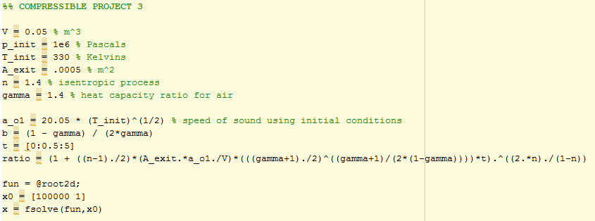

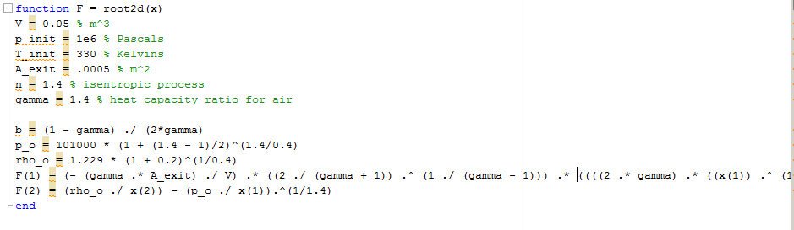

To solve this problem, I attempted to replicate the Stage I analysis. To do this, I input the system properties such as volume, initial pressure, initial temperature, exit area, and gamma and n numbers. By having these characteristics, we are able to analyze the system at hand to find the specified ratio.

My initial thought to analyze this system was using an iterative method. This iterative method would be used to solve for po1 and ρo1. There are two equations which we can use to solve for these values:





In MATLAB, there is a function called fsolve which allows the user to solve nonlinear equations. In our case, we have two equations and two unknowns—a perfect scenario. Unfortunately, when the code was implemented, I received an error about the values not converging so I decided to take an alternate solution. I was able to find this equation:

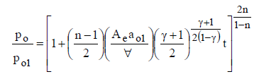

Which demonstrates a relationship with the desired ratio and time. Once inputting this equation into MATLAB and using a row vector for time, we can plot the po/po1 ratio versus time.

